**VERTICAL GARDEN INSTRUCTIONS**

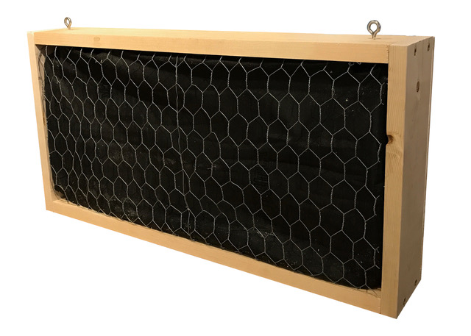

**COST:**

Total cost $47.39. The cost is based on market pricing in Atlanta, GA and does not include tax.

**SKILL LEVEL:** Intermediate

**TOOLS USED:**

Circular saw, Drill, 1/8” drill bit, Heavy duty stapler, 18-Gauge brad nailer, Snips, Scissors, Measuring tape or Carpenter’s Square, Pencil, Safety Goggles, Sanding Block

**TIME TO COMPLETE:**

45 minutes

**MATERIALS:**

(1) 1” x 4” x 96” common board (SKU:914681; $4.67)

(1) 2’ x 4’ x 15/32” plywood (SKU:300896; $9.45)

(1pk) #208 x 1-3/8 in. Stainless-Steel Screw Eye (2-Piece) (SKU:465131; $1.18)

(1) Roll of 1 in. x 2 ft. x 10 ft. Poultry Netting (SKU:771283; $5.98)

(1) Roll of 3 ft. x 50 ft. Polyethylene Weed Barrier Landscape Fabric (SKU:1001014753; $12.98)

(1) Box of heavy duty staples (SKU:172618; $2.76)

(1) Box of 1-1/4” 18-gauge brad nails (SKU:549061; $4.72)

(1pk) #8 x 1-1/2 in. Phillips Flat-Head Wood Screws (8 per Pack) (SKU:380461; $1.18)

(1) 0.75 cu. ft. All Purpose Garden Soil (1001209137; $4.47)

## (optional) Paint or stain

**CUT LIST (see Cut Diagram):**

(2) 24” top/bottom sections from the 1” x 4” x 96” common board

(2) 12” side sections from the 1” x 4” x 96” common board

(1) 25-1/2” x 12” rectangle from the 15/32” x 2’ x 4’ plywood

**CUT DIAGRAM:**

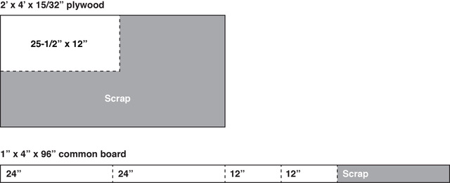

**MEASURE AND MARK CUTS**

* Using the measuring tape, measure and mark cuts with a pencil according to the cut list. You will have marked (2) 24” segments and (2) 12” segments on the 1” x 4” x 96” common board, and (1) 25-1/2” x 12” rectangle on the 2’ x 4’ x 15/32” plywood.

**MAKE CUTS**

* Use a circular saw to make the marked cuts on the 1” x 4” x 96” common board and to cut the marked rectangle from the plywood.
* **TIP:** Use sanding block to smooth any rough edges.

**PAINT OR STAIN AND FINISH (optional)**

* Paint or stain all cut pieces and crates prior to assembly.

**BUILD THE FRAME**

* Place the top and bottom 24” boards horizontal, parallel, and standing on their 1” ends. Align the two 12” side segments so that one is on each left and right side of the 24” segments and forms the shape of a frame. Using the drill and 1/8” Drill Bit, pre-drill two holes per corner from the outside of the 12” side segments into the ends of the 24” top and bottom segments. Use two wood screws per corner to attach the 12” side segments to the 12” top/bottom segments.

**ATTACH CHICKEN WIRE, LANDSCAPING CLOTH, AND FILL WITH SOIL**

* Roll out chicken wire and using a heavy-duty stapler, staple one end of the chicken wire inside of the frame along the 24” top. Press wire so that it is flush and taut to the opening of the frame and secure with staples along the inside of the 24” bottom. Use a pair of wire snips to cut the excess chicken wire once secured to both top and bottom.
* Repeat with the landscaping cloth so that it is secured with staples beneath the chicken wire on the frame. Trim excess cloth with scissors.
* With the wire side facing down, fill the frame with soil.

**ATTACH PLYWOOD BACK**

* Place the 25-1/2” x 12” rectangle plywood on top of the frame filled with soil and attach to all sides of the frame using and 18-gauge brad nailer and brad nails.

**ATTACH EYE HOOKS**

* Stand box on 24” bottom and using the 1/8” drill bit, pre drill centered holes 2” from the left and right ends through the top of the frame for the eye hooks. Screw in eye hooks for hanging.

**CREATE HOLES FOR PLANTS**

* Lay box flat on its plywood back. Using scissors or a knife, cut or punch a small hole in the landscaping fabric beneath the chicken wire holes. Insert plants through the chicken wire hole and into the soil beneath the landscaping fabric.
* **TIP:** If needed, use your fingers to expand the hole in the fabric in order to get a plant’s roots inserted beneath the landscaping fabric and into the soil below.